**Module 5 Assignment(ACCESS)**

Transformation:

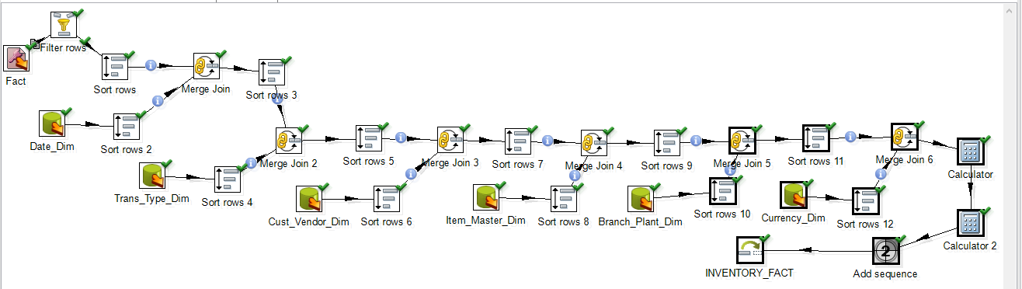

11 rows were inserted.

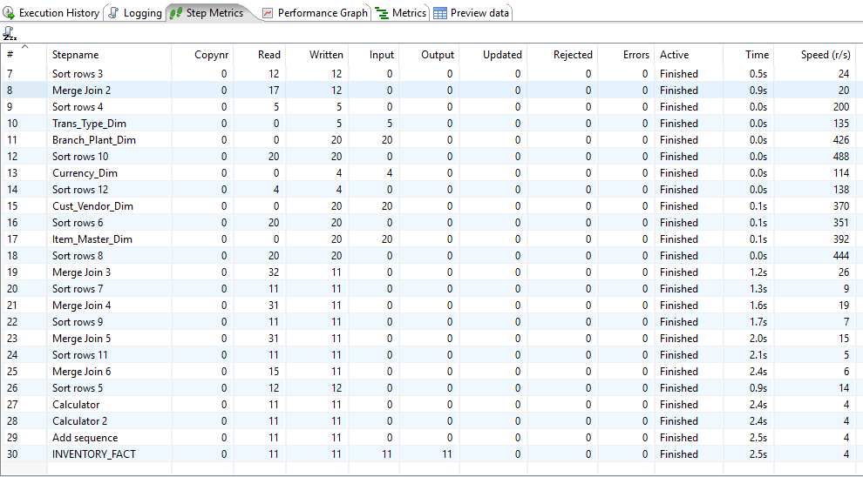

SQL screenshot -

